**RoFin (Adaptive Human Computer Interaction Project)**



***Use Case Specification Document***

**AA-01**

**AR/VR Implementation of RoFin (Adaptive HCI)**

**Version No. 1.0**

**Project Document Revision History**

| **VersionNumber** | **Date** | **Revision Author** | **Description of Revision** |
| --- | --- | --- | --- |
| 1 | 10/16/2024 | Deniz K. Acikbas | Original Revision |

| **Table of Contents** |
| --- |

**1.** **INTRODUCTION 4**

**2.** **USE CASE INFORMATION 4**

2.1 Actors 4

2.2 Use Case Interaction 4

**3.** **TRIGGER 4**

3.1 Camera Initiatilization 4

3.2 LED Glove Initialization 4

3.3 Smart Phone Initialization 4

**4.** **PRE-CONDITION(S) 4**

4.1 Mobile Application 4

4.2 Camera 4

4.3 LED Gloves 4

4.4 AR/VR Glasses 4

**5.** **POST-CONDITION(S) 5**

5.1 Successful Human Computer Interaction 5

5.2 Server Exception – Server Processing Error 5

5.3 Server Exception – No Internet Connection 5

5.4 Server Exception – Connection Interrupted 5

5.5 Hardware Exception – Hardware Error 5

5.6 Hardware Exception – Hardware Not Detected 5

5.7 Hardware Exception – Hardware Not Compatible 5

**6.** **USE CASE SWIMLANE (ACTIVITY) DIAGRAM 6**

**7.** **MAIN/BASIC FLOW(S) OF EVENTS (HAPPY PATH) 8**

7.1 User successfully interacts with the graphical user interface with LED gloves (Completed Path) 8

**8.** **ALTERNATE/EXCEPTION FLOW OF EVENTS 9**

8.1 Server Exception 9

8.2 Hardware Exception 9

**9.** **ASSUMPTIONS/BUSINESS RULES INCLUDING NON-FUNCTIONAL REQUIREMENTS 9**

9.1 Functioning Mobile Phone with Camera 9

9.2 Visible Environment 9

9.3 Functioning AR/VR Glasses 9

**10.** **USE CASE SPECIFICATION REVIEW AND SIGNOFF 10**

# **Introduction**

This document outlines the business requirements for an AR/VR system where users interact with a virtual environment through a graphical user interface (GUI) using LED gloves for finger movements and a mobile phone’s built-in camera for real-time gesture tracking. The system focuses on capturing and simulating hand gestures, allowing users to interact seamlessly with virtual objects, buttons, and icons in the AR/VR environment. The goal is to provide a smooth and intuitive user experience while focusing on business operations, without delving into technical or IT-related specifics.

A separate Use Case Summary document provides an overview of how the individual use cases interact within the system, ensuring all functionalities are captured efficiently. This structure helps to avoid over-complicating the user experience while making sure that no critical interactions are missed.

Each use case is designed to cover essential business needs in a straightforward manner, ensuring that the AR/VR system's core functions are well addressed, offering a natural and immersive experience for the user.

# **Use Case Information**

## **2.1. Actors**

| Actor Name | Role | Description |
| --- | --- | --- |
| User | Main | Uses LED gloves and the mobile phone's camera to track hand movements and interact with virtual objects in the AR/VR environment. |

## **Use Case Interaction**

This use case, the AR/VR Use Case, is central to the system and connects with other functional components. Its predecessor is the setup process for the camera and LED gloves, ensuring the hardware is ready for gesture tracking. As a successor, it leads into actions like gesture simulation, interaction with virtual objects, and real-time feedback in the AR/VR environment. These interactions ensure seamless operation from setup to gesture capture and virtual engagement, enhancing the user experience.

# **Trigger**

## **3.1. Camera Initialization**

The camera is activated, and the system checks for proper connection and calibration, ensuring it is ready to capture hand and finger movements accurately.

## **LED Glove Initialization**

The LED gloves are powered on and paired with the app, with the system confirming that all sensors are working correctly and are ready for use in gesture tracking.

## **Smart Phone Initialization**

The smartphone’s system is initialized, ensuring all required components (camera, Bluetooth, or wired connections) are active and ready to support the AR/VR interaction.

# **Pre-condition(s)**

## **Mobile Application**

The mobile application must be installed and running on the user's device, with all necessary permissions granted for accessing the camera and Bluetooth functionality.

## **Camera**

The rolling shutter camera must be properly connected to the mobile app, and it should be powered on and ready to capture hand movements.

## **LED Gloves**

The LED gloves must be charged, powered on, and paired with the mobile app, ensuring that all sensors are functioning correctly for gesture tracking.

## **AR/VR Glasses**

The AR/VR glasses must be properly connected and calibrated to ensure they provide the user with an immersive virtual environment where gesture tracking and interactions can take place smoothly.

# **Post-condition(s)**

## **Successful Human-Computer Interaction**

After the use case is completed, the user successfully interacts with the virtual environment, using hand and finger movements tracked by the AR/VR system. The interaction includes manipulating virtual objects, buttons, and icons through gestures.

## **Server Exception – Server Processing Error**

If the server fails to process the gesture data, whether on a mobile phone or AR/VR device, the system will notify the user and attempt to retry the connection or processing.

## **Server Exception – No Internet Connection**

The system detects the absence of an internet connection on the mobile phone or AR/VR device, prompting the user to reconnect or wait until connectivity is restored.

## **Server Exception – Connection Interrupted**

If the connection to the server is interrupted during processing, the system will notify the user on the mobile or AR/VR device and attempt to reestablish the connection.

## **Hardware Exception – Hardware Error**

A hardware malfunction, such as an issue with the camera or LED gloves, prompts an error message, and the system will attempt to troubleshoot or instruct the user on resolving the issue.

## **Hardware Exception – Not Detected**

If the camera or LED gloves are not detected, the system will alert the user, prompting them to check connections and ensure all hardware is properly configured.

## **Hardware Exception – Not Compatible**

If the hardware being used (camera or gloves) is incompatible with the AR/VR system, the user will be notified and provided with options for compatible hardware or system settings adjustments.

# **Use Case Swimlane (Activity) Diagram**

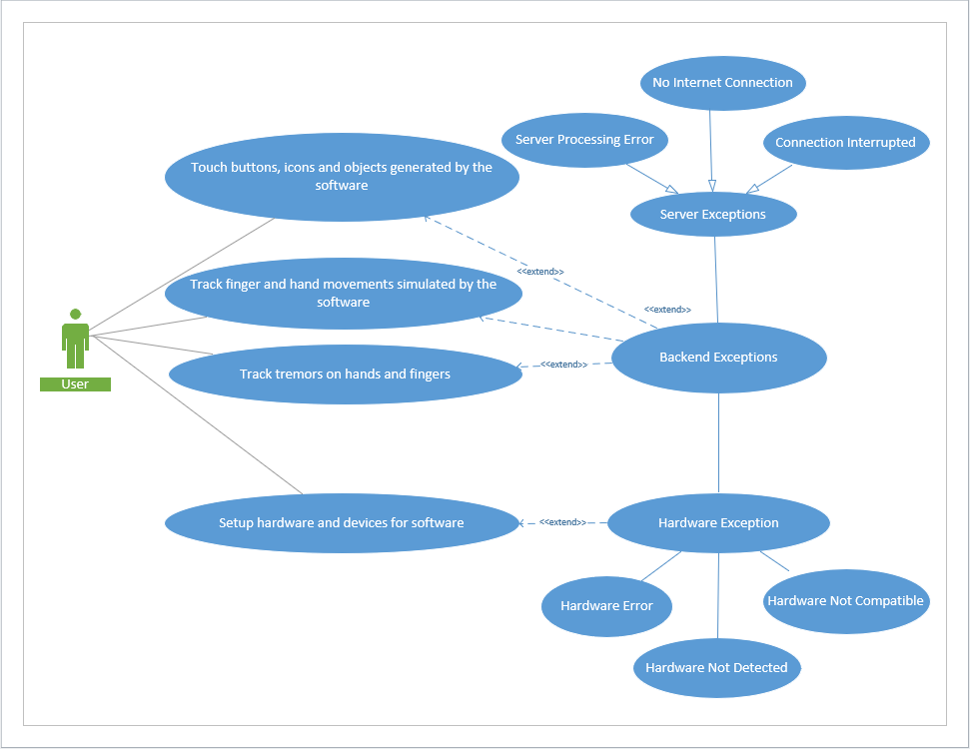

# **Main/Basic Flow(s) of Events (Happy Path)**

## **User successfully interacts with the graphical user interface using LED gloves (Completed Path)**

1. The user puts on the LED gloves and opens the AR/VR system, accessing the graphical user interface (GUI).
2. The user initiates the interaction by clicking the "Start Interaction" button within the AR/VR system.
3. The system activates the mobile phone's camera and LED gloves, beginning real-time tracking of the user's hand and finger movements.
4. The camera captures hand gestures while the LED gloves detect finger movements, sending this data to the AR/VR system.
5. The AR/VR system processes the input, allowing the user to interact with virtual objects, buttons, and icons in the GUI through gestures.
6. The system displays the real-time interaction within the AR/VR environment, reflecting the user’s movements precisely.
7. The user can end the interaction at any time by selecting the "Stop Interaction" button, which saves the interaction data for future use or analysis.

# **Alternate/Exception Flow of Events**

## **Server Exception**

1. The user attempts to interact with the AR/VR system, but the server fails to process the request.
2. In the case of a **Server Processing Error**, the system notifies the user and attempts to retry the request or suggests an alternative action.
3. If there is **No Internet Connection**, the system alerts the user of the connectivity issue and pauses further interaction until the connection is restored.
4. If the **Connection is Interrupted** during use, the system will notify the user and attempt to reestablish the connection, pausing the interaction if necessary.

## **Hardware Exception**

1. The user initiates the interaction, but a hardware issue occurs with the camera or LED gloves.
2. If there is a **Hardware Error** with the gloves or camera, the system will notify the user to check the device and retry the connection.
3. If the hardware is **Not Detected**, the system will prompt the user to ensure all components are properly connected and powered on.
4. If the hardware is **Not Compatible**, the system will inform the user that the connected devices do not meet the requirements for proper interaction, suggesting compatible alternatives.

# **9. Assumptions/Business Rules including Non-Functional Requirements**

**9.1 Functioning Mobile Phone with Camera**

**Assumption:** The mobile phone being used must have a fully functional camera capable of supporting the application’s real-time gesture tracking features.

**Non-Functional Requirement**: The camera must capture high-quality images at a sufficient frame rate to support smooth, real-time processing of hand gestures without significant lag or distortion.

**9.2 Visible Environment**

# **Assumption:** The user must be in a well-lit environment where the camera can clearly capture hand and finger movements for accurate gesture recognition.

**Non-Functional Requirement**: The system should be able to function in varying lighting conditions, with algorithms that adjust for low light or excessive brightness to ensure accurate gesture detection.

**9.3 Functioning AR/VR Glasses**

**Assumption:** The AR/VR glasses being used must be fully functional and compatible with the mobile phone’s camera and LED gloves to support real-time gesture tracking and virtual interactions.

**Non-Functional Requirement**: The AR/VR glasses must display high-quality visuals with minimal latency, ensuring smooth, real-time interaction between the user’s hand gestures and the virtual environment.

# **Use Case Specification Review and Signoff**

| Review and Signoff of the Use Case Specification | | | |
| --- | --- | --- | --- |
| Name | Project Team Role | Signature | Date |
| Soham Naik | Lead Image Processing & Computer Vision Engineer | [Soham Naik](mailto:sohamn@umich.edu) | 10/16/2024 |
| Deniz Acikbas | Lead Mobile App & VR/AR Engineer | [Deniz Acikbas](mailto:dacikbas@umich.edu) | 10/16/2024 |
| Zaynab Mourtada | Lead Machine Learning Engineer | [Zaynab Mourtada](mailto:zaynabmo@umich.edu) | 10/16/2024 |
| Alan Raj | Lead 3D Visualizer Engineer | [Alan Raj](mailto:alanraj@umich.edu) | 10/16/2024 |
| Xiao Zhang | Client |  | 10/16/2024 |